**DAILY ONLINE ACTIVITIES SUMMARY**

|  |  |  |  |  |  |  |  |
| --- | --- | --- | --- | --- | --- | --- | --- |
| **Date:** | **27-06-2020** | | | | **Name:** | **B.A.SOHANKUMAR** | |
| **Sem & Sec** | **4TH SEM A** | | | | **USN:** | **4AL18CS013** | |
| **Online Test Summary** | | | | | | | |
| **Subject** | | **DATA COMMUNICATION** | | | | | |
| **Max. Marks** | | **30** | | **Score** | | **27** | |
| **Certification Course Summary** | | | | | | | |
| **Course** | **INTRODUCTION TO INFORMATION SECURITY** | | | | | | |
| **Certificate Provider** | | | **GLA** | **Duration** | | | **5.5 HOURS** |
| **Coding Challenges** | | | | | | | |
| **Problem Statement: C program to print KTH digit.** | | | | | | | |
| **Status:EXECUTED** | | | | | | | |
| **Uploaded the report in Github** | | | | **YED** | | | |
| **If yes Repository name** | | | | **LOCKDOWN CODING** | | | |
| **Uploaded the report in slack** | | | | **YES** | | | |

**ONLINE TEST DETAILS:**

Today there was a online test on module 5 of DATA COMMUNICATION.The duration of the test was 30 minutes from 11.30am to 12.00pm.Questions were of multiple choice.Score I received is 27/30.

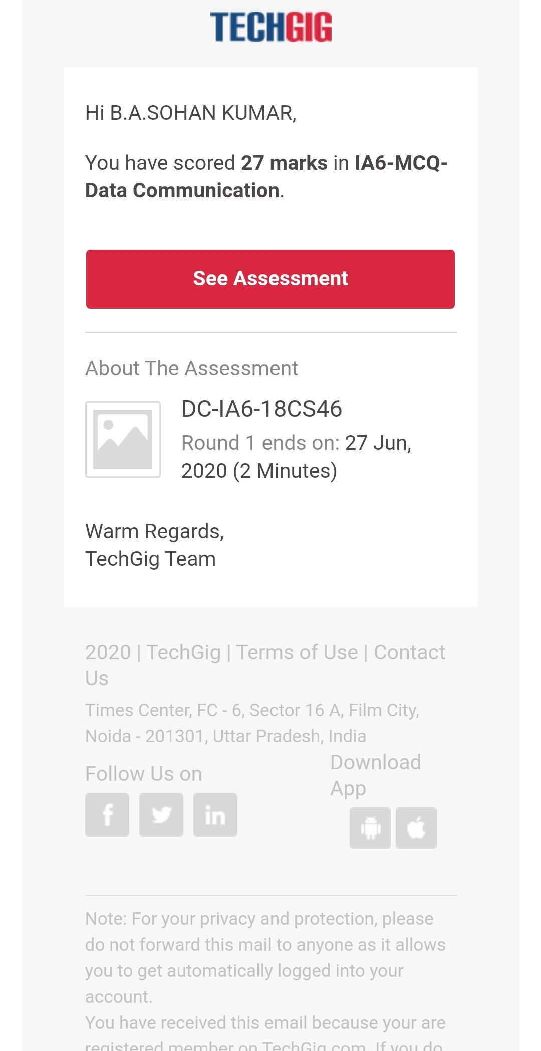

**CERTIFICATION COURSE DETAILS:**

Course: Introduction to information security

Today I have opted this new course and this course has a video content of 5.5 hours.Completed modules today are Intro to Stanford and Computer Security Field,Computer Security - Its applications and its future,Innovations in Cybersecurity - Quantum Computing,What is the future of cryptography؟,Introduction to Software Security Lesson 1.

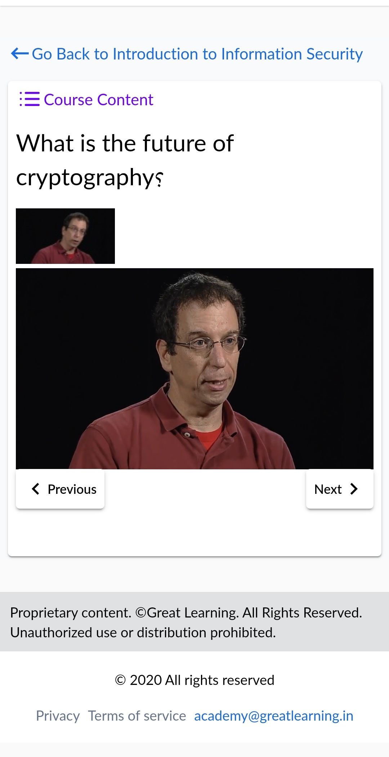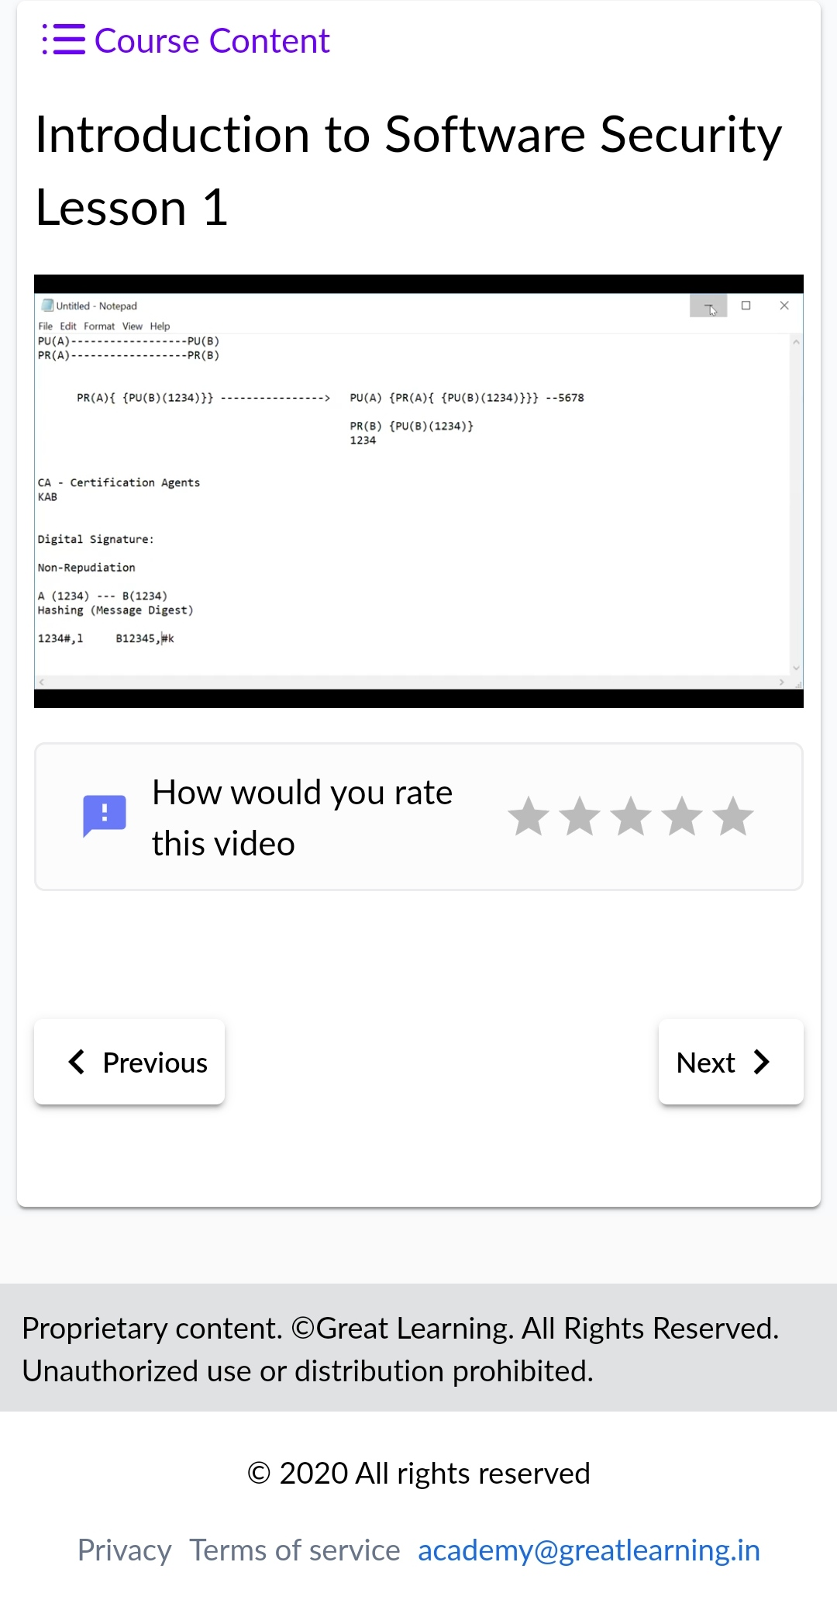

**CODING CHALLENGES DETAILS:**

1.Write a c program to print kth digit.

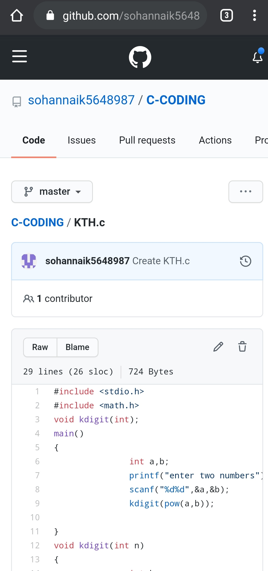

REPOSITORY LINK:https://github.com/sohannaik5648987/C-CODING